Ideation Phase
Define the Problem Statements

Date | 30 September 2026
Team ID | Team 7
Project Name | Streamlining IT Procurement: Automating Standard Laptop Orders with Flow Designer
Maximum Marks | 2 Marks

Customer Problem Statement Template:
Create a problem statement to understand your customer's point of view. The Customer Problem Statement template helps you focus on what matters to create experiences people will love.
A well-articulated customer problem statement allows you and your team to find the ideal solution for the challenges your customers face. Throughout the process, you’ll also be able to empathize with your customers, which helps you better understand how they perceive your product or service.

Reference: https://miro.com/templates/customer-problem-statement/
Example:
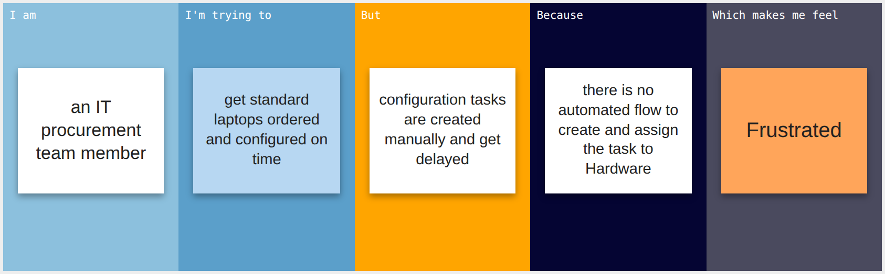
Problem Statement (PS) | I am (Customer) | I’m trying to | But | Because | Which makes me feel
PS-1 | IT procurement team member | order standard laptops and get them set up promptly | tasks are created by hand and often delayed | there is no automated flow to assign the task to Hardware | Frustrated and overloaded
PS-2 | Employee requesting a standard laptop | receive a ready-to-use laptop quickly | I wait long with no updates | Hardware is not assigned automatically | Anxious and unproductive

